Complete a Disclosure of Financial Relationships: Faculty/Presenters
To complete a Disclosure of Financial Relationships form in CloudCME for a UVA CE presentation: Log in to UVA’s CloudCME website: https://uva.cloud-cme.com/
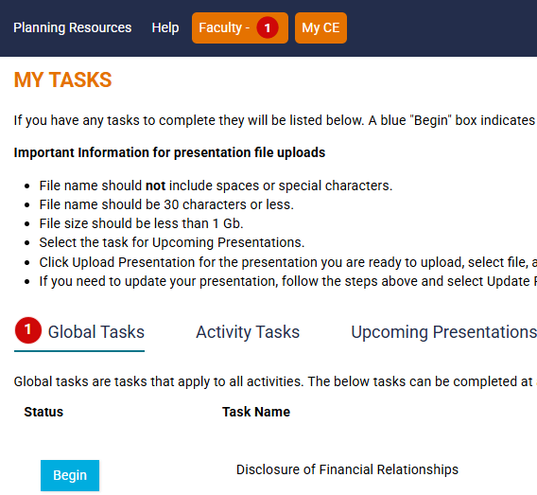
Once signed in, click on the Faculty tab.  Here (1) indicates a global task to complete disclosure. Next, click Begin. If you’ve completed a disclosure previously, you will click on Update.

Complete the form, type in your name, and click “Submit.”

